

M2300 Release Notes

For January 14 2019 Release V27.014

Contents

1 Release Details 3

1.1 Files 3

1.2 Changes 3

1.3 Known Limitations 3

2 Installation 4

2.1 General 4

2.1.1 Initial Setup 4

2.1.2 Transfer a File 4

2.2 Add Signed File Capability 5

2.3 Upgrading from an RMM. 6

2.3.1 Uploading firmware to an RMM. 6

# Release Details

## Files

|  |  |  |
| --- | --- | --- |
| Component | Filename | Date |
| Firmware | M2300_121319 | December 13,2019 10:00 |
| Controller Board | M2300_CTL_888_ETH_RorP_04181916rbf | April 18 2019 16:00 |
| 1553 Board | M1553_1xN_Events_12121909.rbf | December 12, 2019 09:00 |
| Video Boards | M2300VID_06190814.rbf | June 19,2008 14:00 |
| PCM Board | CLX_888_PCM_01132009rbf | January 13,2020 09:00 |
| Ethernet Kernel | M2300-eth-kernel-Feb-20-18-11_17-AM.bin | February 20, 2018 11:00 |

## Changes

1. Fixed issues with UART Channel at 460800 Baud Rate.
2. Fixed Pause/Resume
3. Added New Event System

## Known Limitations

1. Aggregate Data Rate of 23 MB/s
2. Ethernet Data Rate 40% of 100Mb

# Installation

## General

Follow the update procedures shown in the following sections. When updating multiple components do **NOT** restart the recorder until all components have been updated. Follow the steps in section 2.2 once to add the RMM upgrade ability. From then on all upgrades will be done through the RMM as shown in section 2.3.

### Initial Setup

1. Open CALCULEX MONSSTR Setup and Control Utility (SCU).
2. Select the COM port that the recorder is connected to.
3. Turn on the recorder.
4. Wait until a ‘*’ command prompt appears.
5. Type ‘..exit’ and press enter, this will take you to the Linux command prompt.
6. Close SCU.
7. Open HyperTerminal and connect to the same COM port.
8. Press enter to get the command prompt.
9. Change to the temporary directory by typing ‘cd /tmp’ and pressing enter.

### Transfer a File

1. Ensure that you are connected to the recorder and in the temporary directory by following the instructions in the section.
2. Type ‘lrz’ at the command prompt and press enter.
3. In the HyperTerminal application select the ‘Send File…’ option under the ‘Transfer’ menu.
4. In the ‘Send File’ Window that appears click the ‘Browse…’ button and select the file that you want to send. Press the ‘Send’ button to start the transfer.
5. The transfer progress window will close when the transfer is complete.

### Upgrading from Versions Previous to 27.006

If upgrading from Versions before V27.006 , you MUST load the firmware file before performing the RMM Upgrade.

1. Follow the steps 2.1.1 and 2.1.2 to upload the file “m2300_121319.gz”
2. In the /tmp directory, type in “gzip –d m2300_121319.gz”
3. Copy this file to /usr/calculex with “cp m2300_121319 /usr/calculex/m2300”
4. Type in “sync”
5. You are now ready to upgrade with an RMM, You will need to cycle power at this time.

## Upgrading from an RMM.

### Uploading firmware to an RMM.

1. Connect an RMM to a PC using the FireWire port.
2. Open DVU (Download and Validation Utility) version 3.0 or greater.
3. Select the RMM from the RMM List and press Open. 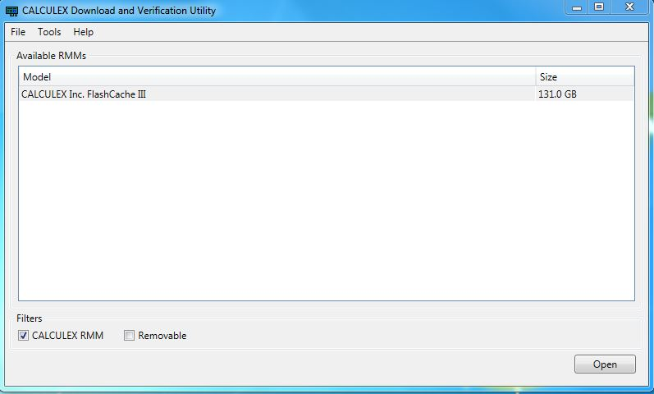
4. Click on the **Command List** or **Advanced** button in the lower left corner. 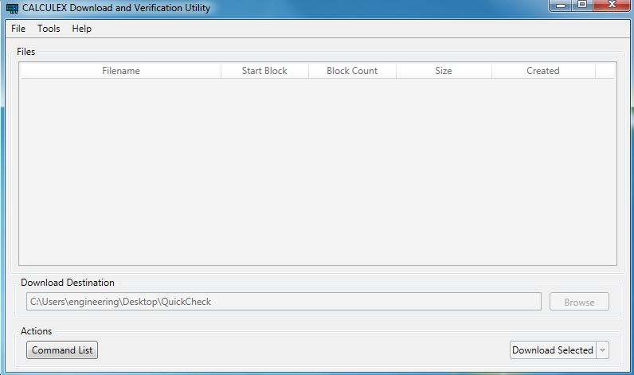
5. Click on the **Upload File** command to select it. 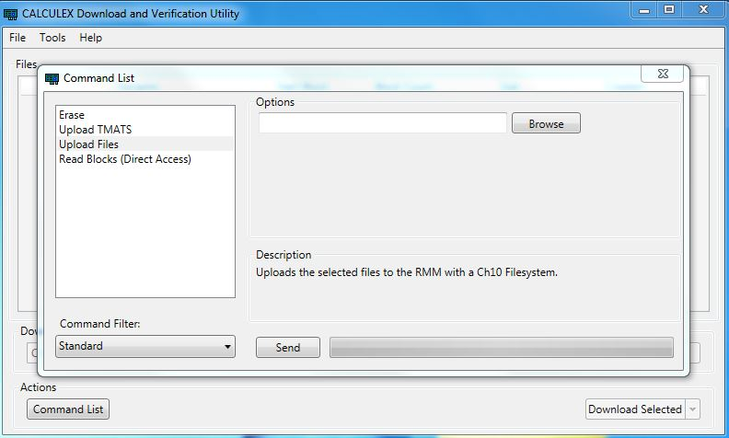
6. Click on the **Browse** button and selecte the recorder_firmware_file_V27.008

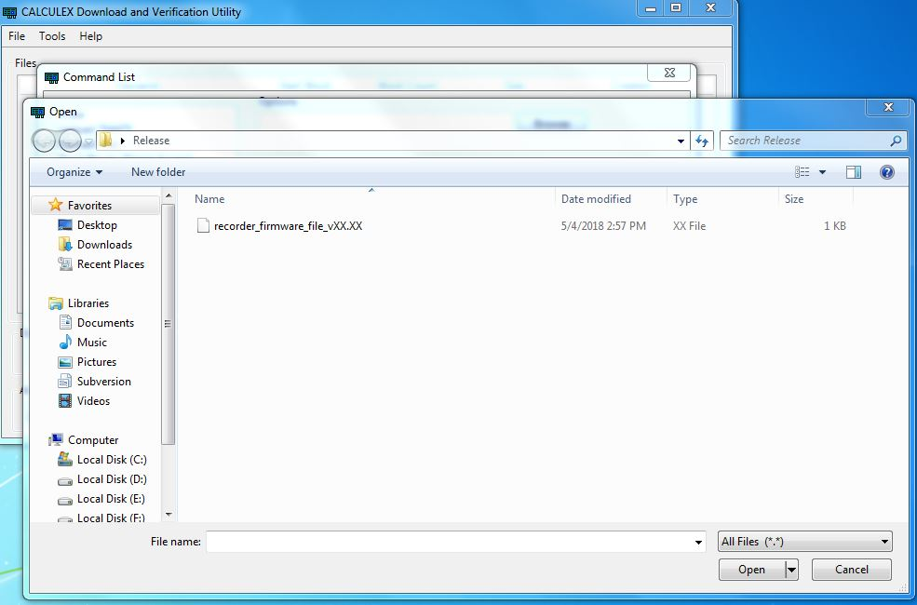

1. Press **Execute**  to upload the firmware file. Warning: This will erase any data currently on the RMM.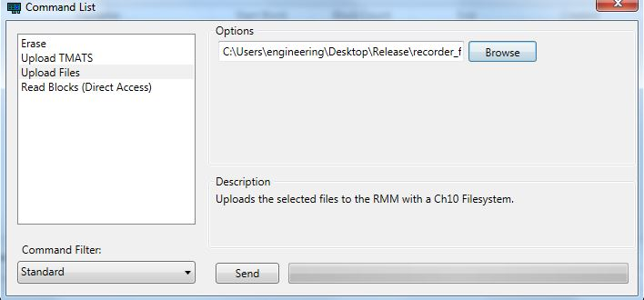
2. Close DVU and Disconnect the RMM from the PC. Power off the recorder if it is turned on. Insert the RMM into the recorder and turn the recorder on. The upgrade shoulde be done automatically by the recorder.
3. . You will know when the upgrade is fully complete when the recorder prints “Upgrade Complete” returns to the star ‘*’ prompt and accepts commands such as **.status.** If a COM port is not connected, The LEDs will stop flashing and the FAULT LED will stay illuminated. Do **NOT** remove the RMM or power off the recorder while the update is in progress. Doing so could cause the recorder to become non-functional and need to be returned for reprogramming.

*

1. Enter a **.erase** command to erase the firmware file from the RMM and prevent the recorder from attempting to update itself again when it is restarted. If updating multiple recorders then you can use the same RMM for all of them all before erasing it as long as the procedures in section 2.2 have already been done on each recorder to give them RMM upgrade capability.